PROJECT ARCHITECTURE
Project: HouseHunt
Technology: MERN Stack
TECHNICAL ARCHITECTURE
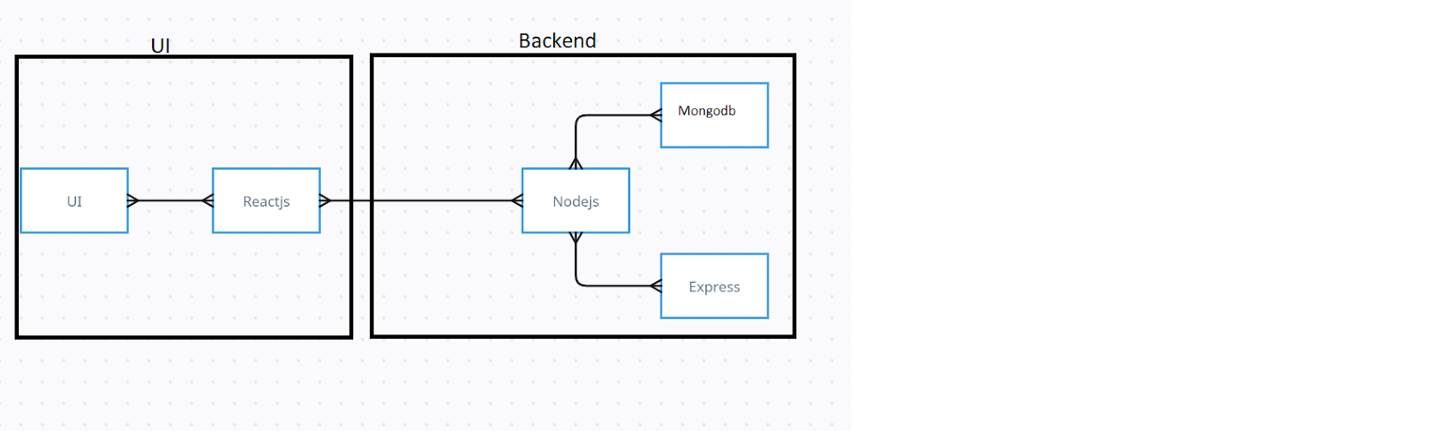
Introduction
The HouseHunt application is designed using a modern MERN (MongoDB, Express.js, React.js, and Node.js) architecture that follows the client-server model. This architecture separates the presentation layer from the business logic, making the application highly scalable, maintainable, and efficient. The frontend acts as the client, providing users with an interactive interface, while the backend serves as the application server responsible for processing requests, executing business logic, and interacting with the database.
The client-server architecture ensures that each component has a well-defined responsibility, enabling smooth communication between the frontend and backend through RESTful APIs. This modular design improves code organization, simplifies maintenance, and allows future enhancements without affecting the overall system.

Frontend Architecture
The frontend of the HouseHunt application is developed using React.js, which provides a component-based architecture for building reusable and dynamic user interfaces. React enables efficient rendering through its Virtual DOM, resulting in improved performance and faster page updates.
To facilitate seamless communication with the backend services, the application utilizes the Axios library. Axios sends HTTP requests to the backend REST APIs and processes server responses efficiently. Through these APIs, users can perform various operations such as:
- User Registration and Login
- Property Search
- Property Listing
- Property Booking
- Viewing Booking History
- Property Management for Owners
- Administrative Operations
For designing an attractive and responsive user interface, the project incorporates Bootstrap and Material UI (MUI). These libraries provide pre-built components, responsive layouts, icons, forms, navigation elements, and modern styling that ensure a consistent user experience across desktop, tablet, and mobile devices.
The frontend is designed to support multiple user roles, including:
- Administrator
- Property Owner
- Customer/User
Each user role is presented with a customized interface and functionality based on authorization and permissions.

Backend Architecture
The backend is developed using Node.js with the Express.js framework. Express.js serves as the middleware layer between the frontend and the database, handling all incoming HTTP requests and returning appropriate responses.
The backend is responsible for implementing the complete business logic of the application, including:
- User Authentication
- Authorization using JWT
- Property Management
- Booking Management
- Administrative Operations
- Data Validation
- Error Handling
- REST API Development
The backend follows the MVC (Model-View-Controller) architecture to organize the codebase into separate layers:
- Models define database schemas.
- Controllers contain business logic.
- Routes define API endpoints.
- Middleware handles authentication and request validation.
This structured architecture improves code readability, maintainability, and scalability.

Database Architecture
The application uses MongoDB Atlas, a cloud-based NoSQL database, for storing and managing application data. MongoDB is chosen because of its flexible document-oriented structure, high performance, and scalability.
The database consists of several collections, including:
User Collection
Stores user-related information such as:
- Name
- Email
- Password (Encrypted)
- User Role
Property Collection
Stores details of rental properties such as:
- Property Name
- Description
- Location
- Price
- Images
- Owner Information
Booking Collection
Maintains booking records including:
- User ID
- Property ID
- Booking Dates
- Total Amount
- Booking Status
Relationships between these collections are managed using MongoDB ObjectIds, allowing efficient retrieval and management of related information.

API Communication
Communication between the frontend and backend is performed using RESTful APIs.
The typical request lifecycle follows these steps:
- The user performs an action through the React interface.
- Axios sends an HTTP request to the Express.js server.
- Express.js processes the request.
- Business logic is executed inside the corresponding controller.
- MongoDB performs the requested database operation.
- The server returns a JSON response.
- React updates the user interface dynamically.
This architecture ensures efficient and secure communication between all application layers.

Authentication and Security
The HouseHunt application implements a secure authentication mechanism using JSON Web Tokens (JWT).
The authentication process includes:
- User Registration
- Password Encryption using bcrypt
- Secure Login
- JWT Token Generation
- Protected Routes
- Role-Based Authorization
Different authorization levels are implemented for:
- Administrator
- Property Owner
- Customer/User
Middleware functions verify user identity before granting access to protected resources.

Technology Stack
Layer | Technology
Frontend | React.js
UI Framework | Bootstrap, Material UI
HTTP Client | Axios
Backend | Node.js
Web Framework | Express.js
Database | MongoDB Atlas
Authentication | JWT, bcrypt
API Type | RESTful APIs
Version Control | Git & GitHub

Advantages of the Technical Architecture
The selected technical architecture provides several advantages:
- Modular and scalable application structure.
- Separation of frontend and backend responsibilities.
- Secure authentication and authorization mechanisms.
- Efficient communication through RESTful APIs.
- Flexible document-based database using MongoDB.
- Responsive and user-friendly interface.
- Easy integration of future features and third-party services.
- Simplified maintenance through the MVC architecture.
- High performance due to React's Virtual DOM and Node.js asynchronous processing.
- Cloud-based database accessibility using MongoDB Atlas.

Conclusion
The technical architecture of the HouseHunt application provides a robust, scalable, and maintainable foundation for developing a modern property rental platform. By integrating React.js, Express.js, Node.js, and MongoDB within the MERN stack, the application ensures efficient communication between the client and server while delivering high performance and a seamless user experience. The use of RESTful APIs, JWT-based authentication, and the MVC design pattern enhances security, maintainability, and overall system reliability. This architecture is well-suited for supporting future enhancements, making HouseHunt a flexible and scalable solution for online property management and rental services.

Entity Relationship (ER) Diagram
Introduction
The Entity Relationship (ER) Diagram is a conceptual representation of the database structure used in the HouseHunt application. It illustrates the major entities, their attributes, primary keys, foreign keys, and the relationships between them. The ER Diagram serves as a blueprint for designing the MongoDB database and helps developers understand how different components of the application interact with each other.
In the HouseHunt application, the database is designed to efficiently manage users, properties, bookings, and booking history while maintaining data consistency and integrity. Each entity represents a real-world object involved in the property rental process, and the relationships between these entities ensure seamless communication throughout the application.

ER Diagram Overview
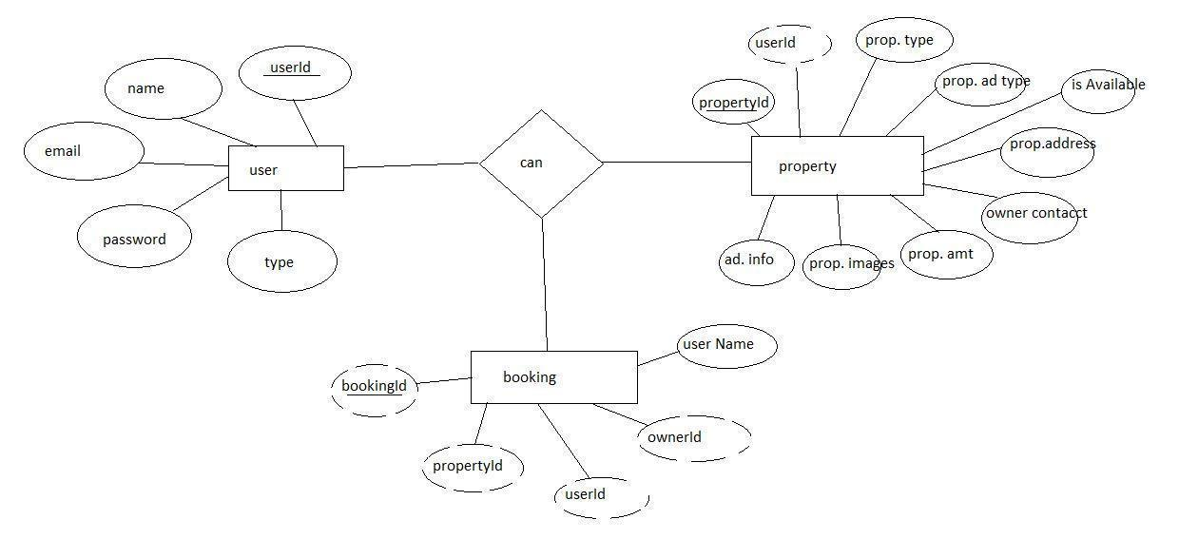
The HouseHunt database consists of four primary entities:
- User
- Property
- Booking
- Booking History
These entities are interconnected through one-to-many relationships, allowing efficient storage and retrieval of application data.

User Entity
Description
The User entity represents every individual registered in the HouseHunt application. Depending on the assigned role, a user may act as a tenant, property owner, or administrator. This entity stores authentication details, personal information, and profile-related data required for accessing the system.
Every registered user has a unique identity that enables secure authentication and authorization within the application.
Attributes
Attribute | Description
UserID (Primary Key) | Unique identifier for each user
Name | Full name of the user
Email | Registered email address used for login
Phone | Contact number of the user
Password | Encrypted password stored securely using bcrypt
UserType | Defines whether the user is an Admin, Owner, or Tenant
ProfileImage | User profile picture
CurrentLocation | Current residential location of the user
Explanation
The User entity forms the foundation of the HouseHunt system. Every operation within the application is associated with a registered user. Property owners can list multiple properties, while tenants can browse available properties and make bookings. Administrators are responsible for managing the entire system.

Property Entity
Description
The Property entity stores detailed information about every property listed on the platform. Each property belongs to a specific property owner and contains all the information required by tenants before making a booking.
Attributes
Attribute | Description
PropertyID (Primary Key) | Unique property identifier
OwnerID (Foreign Key → User) | References the owner of the property
Title | Property title
Description | Detailed property description
Location | Property address or city
RentAmount | Monthly rental amount
PropertyType | Apartment, Villa, Independent House, etc.
FurnishingStatus | Furnished, Semi-Furnished, Unfurnished
Amenities | Facilities available in the property
Images | Property image URLs
Status | Available or Booked
Explanation
Each property is associated with one owner but can receive multiple booking requests over time. Property information helps tenants compare rental options and make informed decisions before making a booking.

Booking Entity
Description
The Booking entity stores all rental booking transactions performed by tenants. Every booking links a tenant with a selected property and records booking duration and status.
Attributes
Attribute | Description
BookingID (Primary Key) | Unique booking identifier
PropertyID (Foreign Key) | References booked property
TenantID (Foreign Key → User) | References tenant who booked
StartDate | Booking start date
EndDate | Booking end date
BookingDate | Date when booking was created
Status | Pending, Confirmed, or Cancelled
Explanation
Whenever a tenant books a property, a new booking record is created. The booking status helps both tenants and owners monitor the progress of booking requests.

Booking History Entity
Description
The Booking History entity maintains historical records of completed bookings and previously viewed properties. It enables users to track their rental history and allows administrators to analyze booking activities.
Attributes
Attribute | Description
HistoryID (Primary Key) | Unique history identifier
UserID (Foreign Key) | References user
PropertyID (Foreign Key) | References property
BookingID (Foreign Key) | References booking
ViewedOn | Date and time when the property or booking was viewed
Explanation
The Booking History entity provides a complete record of previous booking activities, improving transparency and allowing users to revisit past transactions whenever required.

Relationships Between Entities
User → Property (One-to-Many)
Relationship
One property owner can own multiple properties, while each property belongs to only one owner.
User (1)
│
│ owns
▼
Property (Many)
Explanation
This relationship enables property owners to list and manage multiple rental properties through a single account.

User → Booking (One-to-Many)
Relationship
One tenant can create multiple bookings over time.
User (1)
│
│ books
▼
Booking (Many)
Explanation
Each booking belongs to a single tenant, while a tenant may book multiple properties throughout their usage of the application.

Property → Booking (One-to-Many)
Relationship
One property can have multiple booking records across different time periods.
Property (1)
│
│ booked
▼
Booking (Many)
Explanation
Although only one booking may be active during a specific rental period, the property can be booked by different tenants at different times.

User → Booking History (One-to-Many)
Relationship
One user can have multiple booking history records.
User (1)
│
│ history
▼
Booking History (Many)
Explanation
Each booking or property interaction is stored in the booking history, allowing users to review previous activities and bookings.

Database Integrity
The database maintains consistency through the use of Primary Keys and Foreign Keys.
Primary Keys
- UserID
- PropertyID
- BookingID
- HistoryID
Foreign Keys
- OwnerID → User
- TenantID → User
- PropertyID → Property
- BookingID → Booking
- UserID → User
These relationships ensure data consistency, prevent orphan records, and simplify data retrieval across multiple collections.

Advantages of the ER Design
- Provides a well-structured and organized database.
- Reduces data redundancy.
- Maintains data consistency through defined relationships.
- Simplifies CRUD operations.
- Supports scalable property management.
- Enables efficient booking management.
- Improves overall system maintainability.
- Facilitates future feature expansion.

Conclusion
The Entity Relationship Diagram provides a clear representation of how Users, Properties, Bookings, and Booking History interact within the HouseHunt application. Properly defined entities and relationships ensure efficient data storage, secure access, and reliable database operations. This database design supports the application's current requirements while providing flexibility for future enhancements, making it a strong foundation for a scalable property rental management system.
Features
Introduction
The HouseHunt application is designed to simplify the process of searching, listing, and booking rental properties through an intuitive and user-friendly platform. The system provides advanced search capabilities, comprehensive property information, secure booking management, and valuable market insights to assist users in making informed decisions. These features enhance user experience while improving the efficiency of property owners and administrators in managing rental properties.
The application is developed with scalability in mind, allowing additional functionalities to be integrated as the platform grows.

Advanced Property Search
Overview
One of the key features of the HouseHunt application is its Advanced Property Search functionality. Instead of manually browsing through hundreds of listings, users can quickly narrow down suitable properties based on their personal preferences. This feature significantly reduces search time while improving the overall user experience.

Property Filters
The application allows users to apply multiple search filters simultaneously, enabling precise and personalized property searches.
Available Search Filters
- Location
- Price Range
- Property Type
- Property Size
- Number of Bedrooms
- Number of Bathrooms
- Furnishing Status
- Availability Status
- Parking Facility
- Pet-Friendly Properties
- Swimming Pool
- Garden Area
- Garage Facility
- Wi-Fi Availability
- Security Features
These filters help users quickly identify properties that match their requirements without browsing unnecessary listings.

Saved Searches
To improve convenience, HouseHunt allows users to save their frequently used search criteria.
This feature enables users to:
- Save preferred search filters.
- Reuse previous searches without entering information again.
- Quickly access matching properties.
- Receive future updates when similar properties become available (future enhancement).
Saved searches reduce repetitive tasks and improve user engagement with the platform.

Market Insights and Trends
Overview
HouseHunt provides useful market information that helps users make better rental and investment decisions. Instead of displaying only property details, the platform also presents relevant information about the surrounding area and current market conditions.

Property Price Trends
The application displays rental price trends across different locations.
Users can:
- Compare average rental prices.
- Analyze market trends.
- Understand whether rental prices are increasing or decreasing.
- Make informed financial decisions before renting a property.
Property owners can also evaluate competitive pricing before listing their properties.

Neighbourhood Insights
Choosing the right property involves more than just price. HouseHunt provides valuable neighbourhood information to help users evaluate different locations.
Neighbourhood information includes:
- Nearby Schools
- Hospitals
- Shopping Centers
- Public Transport
- Parks
- Restaurants
- Banks
- Crime Rate Information
- Safety Ratings
These details help tenants select properties that best suit their lifestyle and daily requirements.

Investment Potential
HouseHunt also supports users interested in real estate investment.
The platform provides information such as:
- Property Value Appreciation
- Rental Demand
- Area Development
- Market Growth
- Future Investment Opportunities
These insights help investors evaluate long-term profitability before purchasing or renting properties.

Additional Functional Features
Besides the core search functionality, the HouseHunt application provides several essential features that improve overall usability.
User Authentication
The application includes a secure authentication system where users can:
- Register a new account.
- Login securely.
- Reset passwords (future enhancement).
- Maintain secure sessions using JWT authentication.
Passwords are encrypted using bcrypt before being stored in the database.

Property Management
Property owners have complete control over their listings.
They can:
- Add new properties.
- Edit property information.
- Upload property images.
- Update rental prices.
- Remove unavailable properties.
- Manage property availability.

Booking Management
Registered users can easily book available properties.
The booking system allows users to:
- Select booking dates.
- Confirm bookings.
- View booking history.
- Cancel bookings when necessary.
- Track booking status.

Admin Dashboard
Administrators have complete control over the application.
Administrative features include:
- User Management
- Property Management
- Booking Management
- Monitoring Platform Activities
- Removing Invalid Listings
- Managing Registered Users

Responsive User Interface
The application is designed using Bootstrap and Material UI, ensuring a responsive interface across multiple devices.
Users can comfortably access HouseHunt using:
- Desktop Computers
- Laptops
- Tablets
- Smartphones
The responsive design provides a consistent experience regardless of screen size.

Security Features
HouseHunt incorporates several security mechanisms to protect user information and application resources.
Security features include:
- JWT Authentication
- Password Encryption using bcrypt
- Role-Based Authorization
- Protected REST APIs
- Secure Database Communication
- Input Validation
- Error Handling
These measures help maintain data confidentiality and prevent unauthorized access.

Future Enhancements
The modular architecture of HouseHunt allows several advanced features to be integrated in future versions, including:
- AI-Based Property Recommendations
- Real-Time Chat Between Owners and Tenants
- Online Rent Payment Gateway
- Google Maps Integration
- Property Rating and Reviews
- Push Notifications
- Wishlist Feature
- Email Notifications
- Property Comparison Tool
- Virtual Property Tours
- Voice-Based Property Search
- Machine Learning-Based Price Prediction

Advantages of the Features
The implemented features provide several benefits to different types of users.
- Simplifies property searching.
- Saves time through advanced filtering.
- Improves decision-making using market insights.
- Enhances user experience with responsive interfaces.
- Provides secure authentication and authorization.
- Simplifies property management for owners.
- Enables efficient booking management.
- Supports future scalability through modular design.
- Offers valuable investment-related information.
- Improves overall platform reliability and usability.

Conclusion
The features implemented in the HouseHunt application create a comprehensive and user-friendly property rental platform. From advanced property search and intelligent filtering to secure booking management and market analysis, the system is designed to meet the needs of tenants, property owners, and administrators. The modular architecture ensures that additional functionalities can be integrated easily, making HouseHunt a scalable and future-ready real estate management solution
Roles and Responsibilities
Introduction
The HouseHunt application is designed with a Role-Based Access Control (RBAC) system to ensure that each user interacts only with the features relevant to their responsibilities. The platform consists of three primary user roles:
- Tenant (Renter)
- Property Owner
- Administrator (Admin)
Each role is assigned a specific set of permissions and responsibilities that enhance system security, improve user experience, and maintain efficient management of the platform.

Tenant (Renter)
Overview
A Tenant is a registered user who uses the HouseHunt platform to search for rental properties and submit booking requests. Tenants can browse available properties, view detailed property information, and communicate their interest through the booking system.
Responsibilities
The Tenant is responsible for the following activities:
- Register a new account on the platform.
- Securely log in using their registered email and password.
- Browse all available rental properties.
- Search properties using various filters such as location, price, property type, and amenities.
- View complete property information including:
  - Property details
  - Rental amount
  - Amenities
  - Property images
  - Owner information
- Submit booking requests for preferred properties.
- Provide the required personal details while requesting a booking.
- View all submitted booking requests.
- Track the booking status, such as:
  - Pending
  - Confirmed
  - Cancelled
- Manage personal profile information.
- Logout securely from the application.
Permissions
A Tenant can:
- View properties.
- Book available properties.
- View booking history.
- Update personal profile.
- Cancel pending bookings (if permitted).
A Tenant cannot:
- Add new properties.
- Modify existing properties.
- Approve bookings.
- Access administrative features.

Property Owner
Overview
A Property Owner is a verified user authorized to list and manage rental properties on the HouseHunt platform. Before gaining access to owner functionalities, the user must receive approval from the Administrator.
Responsibilities
The Property Owner is responsible for:
- Registering an account on the platform.
- Requesting Owner privileges.
- Receiving approval from the Administrator.
- Adding new property listings.
- Updating property information.
- Uploading property images.
- Editing rental prices.
- Managing property descriptions.
- Updating property availability.
- Viewing booking requests received from tenants.
- Approving or rejecting booking requests.
- Changing booking status.
- Removing inactive property listings.
- Maintaining accurate property information.
Permissions
A Property Owner can:
- Perform Create, Read, Update, and Delete (CRUD) operations on their own properties.
- View booking requests for their properties.
- Update booking status.
- Manage property availability.
A Property Owner cannot:
- Access other owners' properties.
- Manage users.
- Access administrative controls.

Administrator (Admin)
Overview
The Administrator is the highest authority within the HouseHunt application. The Admin manages the overall platform, verifies users requesting owner privileges, monitors property listings, and ensures smooth operation of the system.
Responsibilities
The Administrator is responsible for:
- Managing all registered users.
- Approving users who request Owner access.
- Managing property listings.
- Monitoring booking activities.
- Removing invalid or inappropriate property listings.
- Enforcing platform rules and policies.
- Managing user accounts.
- Monitoring platform performance.
- Ensuring data integrity and security.
- Resolving system-level issues.
- Maintaining overall application functionality.
Permissions
The Administrator can:
- View all users.
- View all properties.
- View all bookings.
- Approve Owner accounts.
- Delete inappropriate users or properties.
- Monitor platform activity.
- Manage the complete application.
The Administrator has unrestricted access to all management functionalities within the system.

Role Comparison
Feature | Tenant | Property Owner | Administrator
Register/Login | ✔ | ✔ | ✔
Search Properties | ✔ | ✔ | ✔
View Property Details | ✔ | ✔ | ✔
Book Property | ✔ | ✖ | ✖
View Booking History | ✔ | ✔ | ✔
Add Property | ✖ | ✔ | ✔
Edit Property | ✖ | ✔ | ✔
Delete Property | ✖ | ✔ | ✔
Manage Property Availability | ✖ | ✔ | ✔
Approve Bookings | ✖ | ✔ | ✔
Approve Owner Accounts | ✖ | ✖ | ✔
Manage Users | ✖ | ✖ | ✔
Manage All Properties | ✖ | ✖ | ✔
Monitor Entire Platform | ✖ | ✖ | ✔

Role-Based Access Control (RBAC)
HouseHunt implements Role-Based Access Control (RBAC) using JSON Web Token (JWT) authentication and authorization middleware. After successful login, each authenticated user receives a JWT containing their unique user ID and assigned role. Every protected API validates the token before granting access.
Role verification middleware ensures that:
- Tenant APIs are accessible only to registered tenants.
- Owner APIs are accessible only to approved property owners.
- Admin APIs are accessible only to administrators.
This approach enhances security by preventing unauthorized users from accessing restricted resources while ensuring that each user interacts only with features appropriate to their role.

Advantages of Role-Based Access
The role-based architecture offers several advantages:
- Improves application security.
- Prevents unauthorized access to protected resources.
- Simplifies user management.
- Provides customized functionality for different user types.
- Enhances maintainability and scalability.
- Protects sensitive administrative operations.
- Ensures efficient management of properties and bookings.

Conclusion
The HouseHunt application follows a well-defined role-based architecture that clearly separates the responsibilities of Tenants, Property Owners, and Administrators. Each role is assigned appropriate permissions based on its purpose within the system, ensuring secure and efficient platform operation. By implementing JWT-based authentication and role-based authorization, the application maintains data integrity, enhances security, and delivers a personalized experience for every user. This structured access control mechanism contributes to the overall reliability, scalability, and maintainability of the HouseHunt platform.

User Flow
Introduction
The User Flow describes the sequence of interactions a user follows while using the HouseHunt application. It provides a clear understanding of how different users navigate through the system, from registration and authentication to property searching and booking. A well-defined user flow improves usability by ensuring that each process is intuitive, efficient, and easy to understand.
The HouseHunt application is designed to minimize the number of steps required for users to find suitable rental properties while maintaining a secure and user-friendly experience.

User Journey
The following flow represents the complete journey of a tenant using the HouseHunt application.
Start
│
▼
Open HouseHunt Application
│
▼
Register / Login
│
▼
Browse Available Properties
│
▼
Apply Search Filters
│
▼
View Property Details
│
▼
Suitable Property Found?
│
┌─┴─────────────┐
│ │
No Yes
│ │
▼ ▼
Continue Submit Booking
Searching │
▼
Booking Status (Pending)
│
▼
Owner Reviews Booking Request
│
┌───────┴────────┐
│ │
Confirmed Cancelled
│ │
▼ ▼
Booking Completed Search Another Property
│
▼
End

Step 1 – Start
The user begins their journey by accessing the HouseHunt platform with the intention of searching for rental properties. This marks the entry point into the application.

Step 2 – Open HouseHunt Application
The user launches the HouseHunt application using a web browser. The responsive interface allows the application to be accessed from desktops, laptops, tablets, and mobile devices.
At this stage, users are presented with the homepage where they can choose to register or log in.

Step 3 – Register or Login
New users create an account by providing basic information such as:
- Full Name
- Email Address
- Password
Existing users log in using their registered email address and password.
After successful authentication, a JSON Web Token (JWT) is generated and used to authorize access to protected resources throughout the application.

Step 4 – Browse Available Properties
Once logged in, users are redirected to the property listing page where all available rental properties are displayed.
Each property includes:
- Property Title
- Images
- Rental Price
- Property Type
- Location
- Availability Status
Users can browse through multiple listings to identify properties that match their preferences.

Step 5 – Search and Filter Properties
To simplify property discovery, users can apply various search filters.
Available filters include:
- Location
- Price Range
- Property Type
- Number of Bedrooms
- Amenities
- Furnishing Status
Filtering allows users to quickly narrow down suitable properties without manually checking every listing.

Step 6 – View Property Details
After selecting a property, users can access detailed information, including:
- Property Description
- Rental Amount
- Owner Information
- Available Amenities
- Property Images
- Availability Status
This information enables users to evaluate whether the property meets their requirements.

Step 7 – Submit Booking Request
If the selected property is suitable, the user submits a booking request by providing the required booking information.
The booking request includes:
- Property Selection
- Booking Dates
- User Details
Once submitted, the booking is stored in the database with an initial status of Pending.

Step 8 – Booking Review by Owner
The property owner receives the booking request and reviews the submitted information.
The owner can either:
- Approve the booking request.
- Reject or cancel the booking request.
This ensures that only valid booking requests proceed further.

Step 9 – Booking Status Update
After the owner's decision, the booking status is updated accordingly.
Possible booking statuses include:
- Pending
- Confirmed
- Cancelled
The tenant can monitor the updated booking status through the booking section of the application.

Step 10 – End
Once the booking process is completed, the user's journey concludes.
If the booking is confirmed, further rental formalities such as agreement signing, property inspection, and payment are handled between the tenant and property owner according to the organization's process.

User Flow for Different Roles
Tenant Flow
Register/Login
│
Browse Properties
│
Apply Filters
│
View Property
│
Submit Booking
│
Track Booking Status

Property Owner Flow
Login
│
Manage Properties
│
Add / Edit / Delete Property
│
Receive Booking Requests
│
Approve or Reject Bookings

Administrator Flow
Login
│
Manage Users
│
Approve Owners
│
Manage Properties
│
Monitor Bookings

Advantages of the User Flow
The HouseHunt user flow offers several benefits:
- Simple and intuitive navigation.
- Faster property discovery through advanced filtering.
- Secure authentication using JWT.
- Efficient property management for owners.
- Transparent booking process.
- Role-based access control for different users.
- Responsive design for multiple devices.
- Easy scalability for future enhancements.

Conclusion
The user flow of the HouseHunt application is designed to provide a seamless and efficient experience for tenants, property owners, and administrators. From secure user authentication to property browsing, booking management, and administrative control, every stage of the workflow is organized to reduce complexity and improve usability. The structured user journey ensures that users can accomplish their objectives with minimal effort while maintaining security, reliability, and scalability throughout the system.

Model-View-Controller (MVC) Pattern
Introduction
The HouseHunt application is developed using the Model-View-Controller (MVC) architectural pattern, one of the most widely adopted software design patterns for building scalable and maintainable web applications. MVC separates the application into three independent layers: Model, View, and Controller. Each layer has a specific responsibility, enabling developers to organize the project efficiently while improving code readability, maintainability, and scalability.
In the HouseHunt project, the MVC pattern is implemented on the backend using Node.js, Express.js, and MongoDB with Mongoose. This architecture allows the application to process user requests, perform business logic, interact with the database, and return appropriate responses through RESTful APIs.

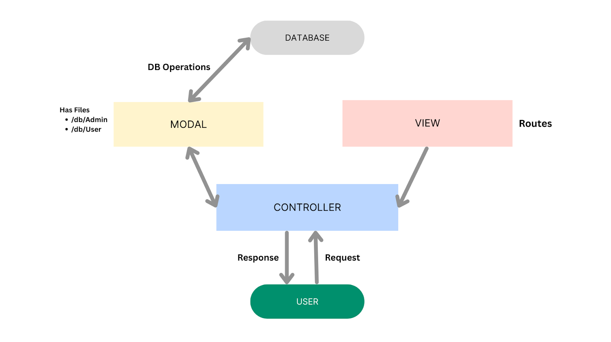
MVC Architecture Overview
The MVC architecture used in HouseHunt can be represented as follows:
User
│
▼
REST API Request
│
▼
Routes (View)
│
▼
Controllers (Logic)
│
▼
Models (Database)
│
▼
MongoDB Atlas
│
▼
JSON Response Returned
│
▼
React Frontend
This layered architecture ensures that each component performs a dedicated function without interfering with other parts of the system.

Model Layer (Data Layer)
Overview
The Model Layer is responsible for managing all application data. It defines the structure of the database using Mongoose Schemas and provides methods for performing Create, Read, Update, and Delete (CRUD) operations.
The model layer communicates directly with MongoDB and acts as the bridge between the application and the database.

Models Implemented
The HouseHunt application contains the following database models:
User Model
The User model stores information about every registered user.
It contains:
- Name
- Email
- Password
- User Role (Admin, Owner, Tenant)
- Contact Details
The password is securely encrypted before being stored in the database.

Property Model
The Property model stores rental property information.
It includes:
- Property Title
- Description
- Location
- Rental Price
- Property Images
- Amenities
- Owner Information
- Property Status
Each property is associated with a specific property owner.

Booking Model
The Booking model manages property booking records.
It stores:
- Tenant Information
- Property Information
- Booking Dates
- Booking Status
- Booking History
The booking model establishes relationships between users and properties.

Responsibilities of the Model Layer
The Model layer is responsible for:
- Defining database schemas.
- Validating data before storage.
- Managing CRUD operations.
- Communicating with MongoDB.
- Maintaining data consistency.
- Enforcing schema validation.

Controller Layer (Business Logic Layer)
Overview
The Controller Layer acts as the central processing unit of the application. It receives requests from the routing layer, processes business logic, interacts with the database through models, and returns appropriate responses to the client.
Controllers ensure that all application rules are executed before data is stored or retrieved.

Controllers Implemented
User Controller
Responsible for:
- User Registration
- User Login
- JWT Token Generation
- Viewing Properties
- User Authentication

Owner Controller
Responsible for:
- Add Property
- Update Property
- Delete Property
- View Own Properties
- Manage Property Availability

Booking Controller
Responsible for:
- Create Booking
- View Bookings
- Cancel Booking
- Update Booking Status

Admin Controller
Responsible for:
- View All Users
- View All Properties
- View All Bookings
- Delete Users
- Approve Property Owners
- Manage Platform Activities

Responsibilities of the Controller Layer
The Controller layer performs the following tasks:
- Receives HTTP requests.
- Validates user input.
- Executes business logic.
- Calls database models.
- Handles exceptions.
- Generates API responses.
- Returns JSON data to the frontend.

View Layer (Routing Layer)
Overview
Since HouseHunt is built as a RESTful API, the View layer is represented by the Express Routing Layer rather than traditional HTML pages. The routing layer defines all API endpoints and maps incoming requests to their corresponding controller functions.
Each route corresponds to a specific feature of the application.

Routes Implemented
User Routes
Handles:
- User Registration
- User Login
- Property Viewing

Owner Routes
Handles:
- Property Management
- Property Updates
- Property Deletion
- Property Listing

Booking Routes
Handles:
- Booking Creation
- Booking Retrieval
- Booking Cancellation

Admin Routes
Handles:
- User Management
- Property Management
- Booking Monitoring
- Administrative Operations

Responsibilities of the View (Routing) Layer
The routing layer is responsible for:
- Defining REST API endpoints.
- Receiving HTTP requests.
- Invoking appropriate controller methods.
- Passing parameters to controllers.
- Returning server responses.

Middleware Integration
The HouseHunt application also includes middleware components that support the MVC architecture.
The middleware performs tasks such as:
- JWT Authentication
- Role-Based Authorization
- Request Validation
- Error Handling
- Protected Route Verification
Implemented middleware includes:
- verifyToken
- verifyAdmin
- verifyOwner
These middleware functions execute before controller methods, ensuring that only authorized users can access protected resources.

Request Processing Flow
The complete request lifecycle in the HouseHunt application follows the sequence below:
Client Request
│
▼
Express Route
│
▼
Authentication Middleware
│
▼
Controller
│
▼
Model
│
▼
MongoDB Database
│
▼
Controller
│
▼
JSON Response
│
▼
React Frontend
This structured workflow improves security, maintainability, and performance.

Advantages of Using MVC
The implementation of the MVC architecture provides several benefits for the HouseHunt application.
- Clear separation of application components.
- Improved code readability and organization.
- Easier debugging and maintenance.
- Simplified feature development.
- High scalability for future enhancements.
- Reusable business logic.
- Better collaboration among multiple developers.
- Independent testing of models, controllers, and routes.
- Improved security through middleware integration.
- Efficient management of large codebases.

Practical Implementation in HouseHunt
The HouseHunt backend follows a modular folder structure based on the MVC pattern.
server/
│
├── config/
├── controllers/
│ ├── userController.js
│ ├── ownerController.js
│ ├── bookingController.js
│ └── adminController.js
│
├── models/
│ ├── UserSchema.js
│ ├── PropertySchema.js
│ └── BookingSchema.js
│
├── routes/
│ ├── userRoutes.js
│ ├── ownerRoutes.js
│ ├── bookingRoutes.js
│ └── adminRoutes.js
│
├── middlewares/
│ └── authMiddleware.js
│
└── server.js
This structure allows each module to be developed and maintained independently while promoting code reusability and scalability.

Conclusion
The Model-View-Controller (MVC) architecture serves as the backbone of the HouseHunt backend, providing a clean separation between data management, business logic, and request handling. By organizing the application into Models, Controllers, Routes, and Middleware, the project achieves better maintainability, scalability, and security. The MVC pattern also simplifies future feature development, enables efficient collaboration among developers, and ensures that the application remains well-structured as it grows. This architectural approach makes HouseHunt a robust and production-ready MERN Stack application suitable for real-world property rental management.

